**Each problem is worth one point. No partial credit will be given. This lab is worth a total of 20 points.**

**Place all answers into ONE .sql file. Attach that file to the Dropbox for Lab 1 in D2L.**

**Only one .sql file will be accepted.**

**\*\*\*\* The following questions use tables from the STUDENT table space \*\*\*\***

**1. Using the DESCRIBE table command, create the following result table using the student**

**employee table.**

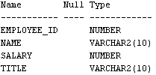

**2. Display all rows and columns within the employee table.**

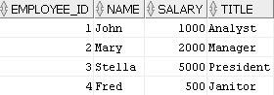

**3. List the students by last name followed by first name. Use the student table.**

**Partial result set (total of 268 rows)**

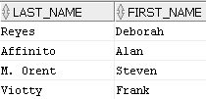

**4. List the students by last name followed by first name. Assign the label “FN” for a**

**student’s first name and “LN” for a student’s last name. Use the student table.**

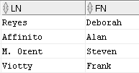

**5. List all unique zip codes. Use the student table.**



**6. List the unique employers of the students and place them in ascending alphabetic order**

**(use the ORDER BY clause). Use the student table.**

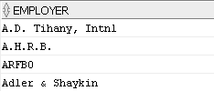

**7. List all students last names without any capitalization. Use the student table.**

**Partial result set (total of 268 rows)**

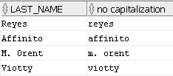

**8. List the first three characters of all course descriptions. Use the course table.**

**Partial result table (total of 30 rows)**



**9. List the last three characters of all course descriptions. Use the course table.**

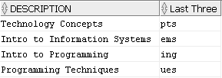

**\*\*\*\* The following questions use the dual table \*\*\*\***

**10. Display all columns and rows of the Dual table.**



**11. Display the sum of 2 + 4 using the DUAL table.**



**12. Display 5 times 3, 5 minus 3, and 5 divided by 3. Use the Dual table.**



**13. Display 5 divided by 3 as a rounded value as per the following result table. Use the Dual**

**table.**



**14. List the current date using the Dual table.**



**15. List yesterday’s date using the Dual table.**

